**This Colonial Hills Civic Association (CHCA) Easter Egg Hunt Event Plan has these sections:**

**A. Activities of the Egg Hunt Chair**

A new event chair should read this section first, and an experienced chair should refer back to it each year to ensure that critical tasks are performed on schedule.

**B. CHCA Egg Hunt Checklist**

This section contains all the tasks for the Egg Hunt Event, and should be printed out, and then checked off by the chair as each task is complete. A checklist is probably the most important tool for a successful project or event of any type, be it a successful airplane flight or a CHCA event!

Note: The activities from the first section, those of the Egg Hunt Chair, are highlighted in yellow in this second Checklist section, for ease of reference.

**C. CHCA Easter Egg Hunt Event: Course Construction**

The first three pages of this section are detailed instructions for constructing the Easter Egg Hunt course, and the last page is a diagram specifying the placement of the stakes which result in the correct dimensions for the course.

**Appendix A - Number Chart**

This is a one-page section, consisting of printed numbers, for which two sets of numbers 1 thru 30 can be printed out on paper with a color printer, or printed in black and white (but on preferably bright colored paper), and then cut up, to place one copy of individual numbers in the plastic eggs and the other copy on the given Easter basket to which the number corresponds - see the Day of Stuffing activities in Section A.

**Appendix B - Signs for the Course Lanes**

These are the set of two-up signs for the lanes for the Easter Egg Hunt Course, which are to be printed, and then cut in half to result in two signs, one for the west end and one of the east end of the lanes for each age group - see Hunt Day activities in Section B.

**Appendix C – Illustrative Photos**

*** ***

Sections A and B were written by longtime (2016-2025) Event Chair Kathi Godber and Section C by Will Pearce (see the original dates and revision history in the footer and in the Comments metadata).

1. **Activities of the Egg Hunt Chair**

**2 months prior:**

Be in touch with officers to confirm dates, be sure that shelter house is reserved, promo is written for web and courier, confirm the sponsors.

* Contact “Bunny Costume” volunteers to get a commitment for the day of the hunt to be in costume from 9:40 – 10:15 or so. We have 2 teen agers who can do the job, or be the alternate: Lauren Curran 614-546-9926 and Eva Kuhne (614) 943-0295. Lauren was the bunny in 2025, Eva was around to help/handle. Maybe they flip next year. The bunny greets kids and poses for photos. She/He should arrive at 9:30 to dress. Be sure they sign the volunteer sign in to get credit for scholarship possibility.

**1 month prior:**

* Get keys to the shelter house, take stock of supplies.

For the 2026 hunt, we have some toys in a box and a bag (maybe 30% of what’s needed, 8-10 baskets left, plenty of grass, plenty of flag tape. There should be about 3 bins of empty eggs, tomato stakes, scissors, tape, (some supplies are in a bin)

* Shop: $500 budget

$250 or so in Toys, baskets, supplies : Walmart, Dollar Tree, Rhode Island Novelty

$250 or so in Candy: Walmart, suckers from RI Novelty, Meijer possibly. Get candy w/ Counts on the bag, try for 1700 pieces – or less.

**Day of Stuffing**

Print 2 sets of numbers (1-30) on bright paper – a number is attached to baskets (Age 0-2 = numbers 1-5, etc)

fill 2 extra just in case a kid comes late and is distraught.

Take all supplies to shelter house. Put up about 6 tables; 3-4 for stuffing eggs w/ candy, and 2 for basket prep. Divy up candy on the 4 tables Put out a volunteer sign-up sheet. Volunteers will help create baskets and fill eggs. Baskets have toys and big or special candy. One of the CHCA officers will bring donuts and coffee.

Divy all the filled eggs among the 6 age bins rather evenly. Place the matching bright basket numbers in eggs (5 to each separate bin). Put prepared baskets on top of eggs and put it all in the storage room.

Clean up mess, vacuum, put away tables, take out garbage

**Hunt Day**

* Print Lane Signs
* Set up 2 tables for baskets.
* Lay out the course – 6 lanes – each is 4 paces wide x 24 paces long. Stake at each end and in the middle – flagging tape along the edges and lanes. Put each age’s basket of eggs in their lane, and tape Age Sign on each Lane at each end. Put up sponsor signage.
* Put out baskets in order of number so they’re easy to locate. 1-5 should be for babies (w/baby stuff)
* Put “Photography disclaimer” on door for all to see; Set out Signup Sheet for Volunteers
* Greet bunny - Be sure they are ready at 9:40. Kids Arrive.
* Announce: welcomes, thank sponsors, tell kids to open eggs to find basket numbers, recycle eggs
* 10 sharp - call the hunt for all except Adult Lane. When kids are done, big kids get their turn
* Hand out baskets won, Clean up, store spare supplies and empty eggs
* Request reimbursement for all expenses from CHCA Treasurer

1. **CHCA EGG HUNT - Checklist Chair duties in yellow**

□ Dates Set: Egg Stuffing______ Hunt __________ Rain Date_________

□ Shelter House Reserved for the 3 events

□ Confirm Sponsors

□ Promo written

□ Confirm Bunny Costume Volunteer

□ Take Stock of Supplies

- Baskets, Toys, Grass, Empty Eggs, Bins, Signs, Stakes, Tape String, Egg #s

□ Quality Check Bull Horn

□ Buy Supplies (keep all receipts)

□ Fb / website promos for □ Stuffing □ Egg Hunt (mid Feb)

□ Order Coffee, Hot Chocolate, Doughnuts

□ Signs Out for Egg Stuffing on Monday before the event

□ Put out signs on the Monday before the Hunt

□ Recruit photographer for the event

□ Get keys for Shelterhouse

STUFFING DAY:

□ Pick up Refreshments

□ Set up for stuffing – Tables, bins, eggs, baskets, candy, toys, numbers

□ Set out signup sheet for school age volunteers;

□ Clean up Shelter house; store eggs and baskets

HUNT DAY:

□ Set up Course ; Hang sponsor signage;

□ Set up tables & baskets with numbers assigned to each

□ Bunny, Photos, Welcome kids, Announce Sponsors and get crowd excited

Ask people to recycle – leave unwanted baskets and plastic eggs

□ Clean up shelter house

□ Collect signs

□ Write Story for the courier (300 words or so)

□ Get reimbursement for expenses

□ Report volunteer hours for high schoolers

SUPPLIES NEEDED FOR THE HUNT:

** take stock of all leftovers from previous year so we don’t have to store much **

*** Don’t use old candy ***

For 2026, we have a small box and a bag of toys for Baskets in storage. Will need some more. We have about 8-10 left over baskets, and lots of basket grass, and plenty of flagging tape.

BUY:

* About 20? pounds of small, indiv wrapped candy for stuffing, maybe 1700 + pieces?
* Some lollipops for baskets (5-10)
* Some bigger candy for baskets, big eggs, chocolate bunnies, Reeses piece carrots (? 10)
* Stuffed animals for baskets
* One or two big special stuffed animals
* Small toys for baskets (gliders, balls, chalk, books, etc. - Rhode Island Novelty.

(be sure to find some toys that are OK for under age 3)

* Baskets (find cheap ones at Walmart or dollar store) 32; (5 for each -6 groups + 2 extra)
* Grass for baskets (there is a good supply for now)

USE FROM STORAGE OR MAKE/BRING:

* Bins for each age group to place prepared eggs (in the storage room)
* Plastic eggs for stuffing – ( 2 or 3 bins full in the storage room)
* Stakes for building the course – in storage room
* Mallet to pound in those stakes, Gloves to protect hands from splinters
* Surveying tape to mark the course (600 – 1000 yards of it)
* Signs for Lanes - Age group, need two signs of each (0-2; 3-4;5-6;7-8; 9-12; 13-Adult)
* Numbers (2 sets – 1 through 30) to put in eggs and on baskets.
* Cellophane tape to attach numbers to baskets , scissors (in Easter Bin) are useful
* Strong tape for the course signage – duct tape
* String and/ or clothesline to hang Signage
* Karaoke machine or Block Blaster back up for megaphones because they never work

Sign in sheets and pens for school aged volunteers to track community service

Donuts, coffee, hot chocolate, cups, napkins for stuffing day. (someone brings this)

Course set up notes – Volunteers (Will and Alan) may be available to help set up the course.

1. **CHCA Easter Egg Hunt Event: Course Construction**

The instructions for constructing the Colonial Hills Civic Association Easter Egg Hunt course have been passed down orally from volunteer to volunteer and/or inferred by a prior year’s observation of the completed artifact. I have documented these instructions herewith to try to improve the efficiency of completing this task.

The diagram on the fourth page of this section shows the layout I remembered from my observation of the completed course during the three previous years I assisted the Event Chair in constructing it, and reflects agreement with the current year’s Event Chair that this layout is appropriate.

The course has six lanes, each approximately 12 feet wide and 72 feet long. 5-foot garden stakes are pounded into the ground at the specified points. The stakes are connected with pink plastic flagging tape to create the lanes.

**Supplies Needed:**

**Garden Stakes:** As shown in the course diagram, 21 stakes need to be pounded. The **5-ft** garden stakes are sold in **bundles of 6**. Therefore the required number of bundles is 4 plus one extra bundle for contingencies (badly bent stakes, stakes possibly being broken in pounding, etc.) = **5 bundles.**

**Pink (“Glow Pink”) Plastic Flagging Tape:** As shown in the diagram, the dimensions of the course are approximately 72 feet wide by 72 feet long. Thus, there are seven 72-feet lengths to be strung with tape, and two 72-feet widths. 7 times 72 feet = 504 feet, plus 2 times 72 feet = 144 feet, for a total stretch of approximately 648 feet. The flagging tape is sold in **rolls of 1 inch x 200 feet**. 648 feet divided by 200 ft/roll = 3.24 rolls. Therefore, the number of rolls needed is 3.24 rounded to the next integer = 4, plus 1 extra roll for contingencies (liberal wrapping around stakes, tape breaking and the broken ends needing to be tied together, etc.) = **5 rolls.**

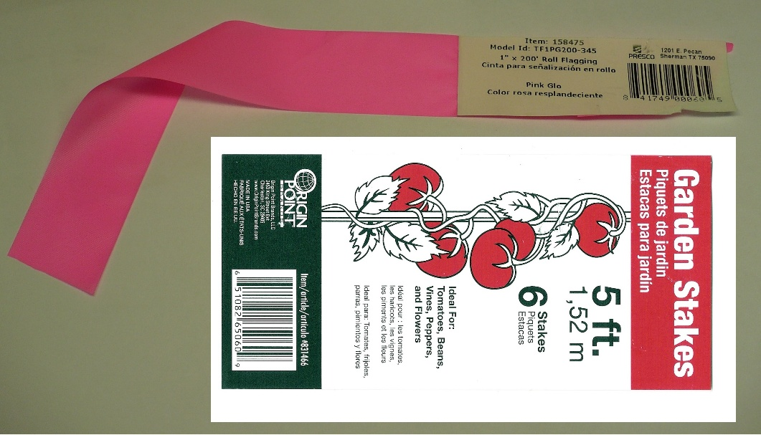

**Tools Needed:**

**Regular Hammer** (to pound the stakes into position)

**Small (Short Handle) Sledge Hammer** (to complete pounding the stakes deep enough not to be knocked over)

**Scissors** (to cut the plastic bindings around the bundles of garden stakes)

**Gloves** (to hold the stakes while pounding to prevent getting splinters)

**Course Construction Instructions:**

1) It is suggested that at least one adult volunteer, plus one assistant (who can be a youth volunteer) begin construction around 8:00 AM on Event Day. This start time should be as directed by the Event Chair, in that access to the Selby Park Shelter House may be needed to obtain the garden stakes and flagging tape (purchasing supplies is the responsibility of the Event Chair), and communication with the Event Chair would be needed in case the event might need to be postponed to the next Saturday due to inclement weather.

An 8:00 AM start time should permit course completion by around 9:00 AM, such that other event volunteers may distribute the eggs in the lanes well before the start of the event at 10:00 AM sharp.

2) Pound the first stake in the northwest corner of the course, about 9 feet away from the basketball hoop (and a few feet away from the newly-planted tree), so as to leave enough room for residents to gather on the grass between the blacktop and the western starting line of the course (line A-A in the diagram), and so that tree(s) are well away from the course.

3) Although you could use a tape measure, I recommend you just pace off four one-yard paces (approximately 12 feet) “due south” from the first stake, and pound the second stake at the end of your fourth pace. After this second stake has been placed, do a “sight check” with reference points located on the homes (or their trees) directly in line with the two stakes, one home to the north and one to the south, to determine where your north-south line will be for the western starting line A-A for the course. Based on this north-south determination, adjust the placement of the second stake as necessary, so that it is along this line. Then, pound each of the remaining 5 stakes in this A-A line, at 4 pace intervals, to complete the starting line.

4) The next stake to be placed is the northernmost stake in the middle of the course, shown as the northernmost point B in the diagram. Thus, start at the northwest point A in the diagram, and pace off one-half of the length of the course heading “due east,” that is 12 paces (36 feet), and pound the stake at this point B. Using a sighting procedure similar to the above, find reference points to the west and to the east (on the homes or playground), and then visualize if you have pounded this stake such that the line A-B is at a right angle (perpendicular) to line A-A. According to this visualization, adjust where you placed stake B accordingly.

5) The next stake to be placed is the one which is 4-paces south of the first point B. The sighting procedure is the same as that used to align the points on line A-A. Thus, after this second stake on the B-B line has been driven, make sure it is in alignment with north-south reference points, and adjust the second stake accordingly. Then, with two stakes on line B-B having been placed, again sight check both of these B-B points with their respective two points on A-A, and adjust the two stakes on line B-B accordingly, such that the two A-B lines are perpendicular to line A-A.

6) After you have made these adjustments with the first two stakes on line B-B, the rest of the stake placement should be relatively easy, as follows:

a. Pound the remaining five stakes to complete the line B-B.

b. Then, starting with the northernmost stake at the far end of the course, at point C, place it to be in alignment with line A-B, to complete the first line A-B-C. Place the next stake due south of this stake, in line with determined north-south reference points, to start line C-C. Then pound the last five stakes in line with both the C-C line and their respective A-B lines.

Note: I found that it is virtually impossible to perform a visual stake alignment by first pounding stakes at the far end of the course, that is, at points C (before I placed the stakes in the B-B line). This distance is just too far from points A, and I would think the only way one could set out the points on line C-C before those on line B-B would be by using a surveying laser or other measuring equipment, which is certainly beyond the scope of this task! (“It’s just an Easter Egg Course!”)

7) String the pink flagging tape around the stakes (to tie the tape to the stakes) and between the stakes to form the six lanes and the two starting lines (one at the west end of the course and one at the east end of the course).

8) Tape the Age-Group signs (“0-2,” “3-4,” etc.) to the flagging tape, in the middle of each lane, at both starting lines. These signs are printed on 8.5 by 11 inch sheets, and are supplied by the Event Chair.

**Course Diagram:**

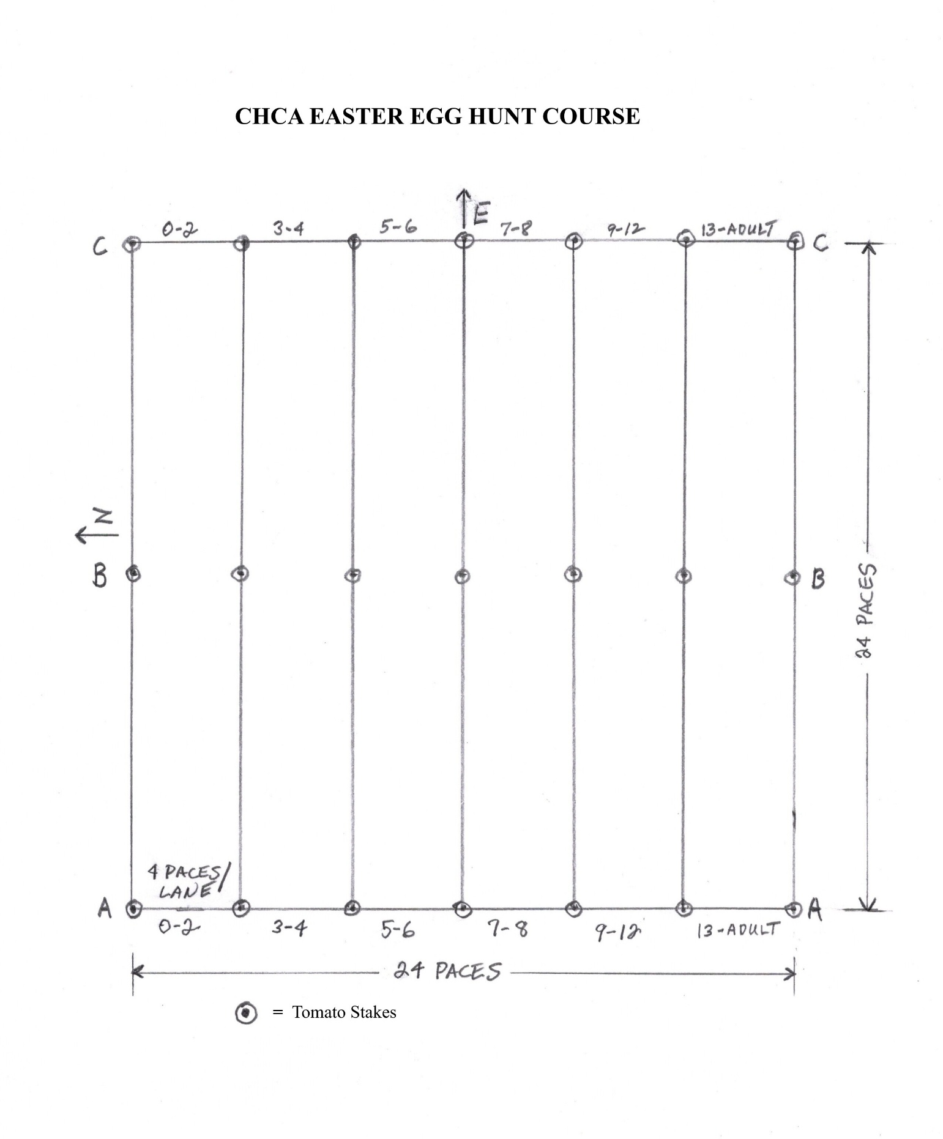

**\*\*\* End of Easter Egg Hunt Course Construction Instructions \*\*\***

**Appendix A - Number Chart**

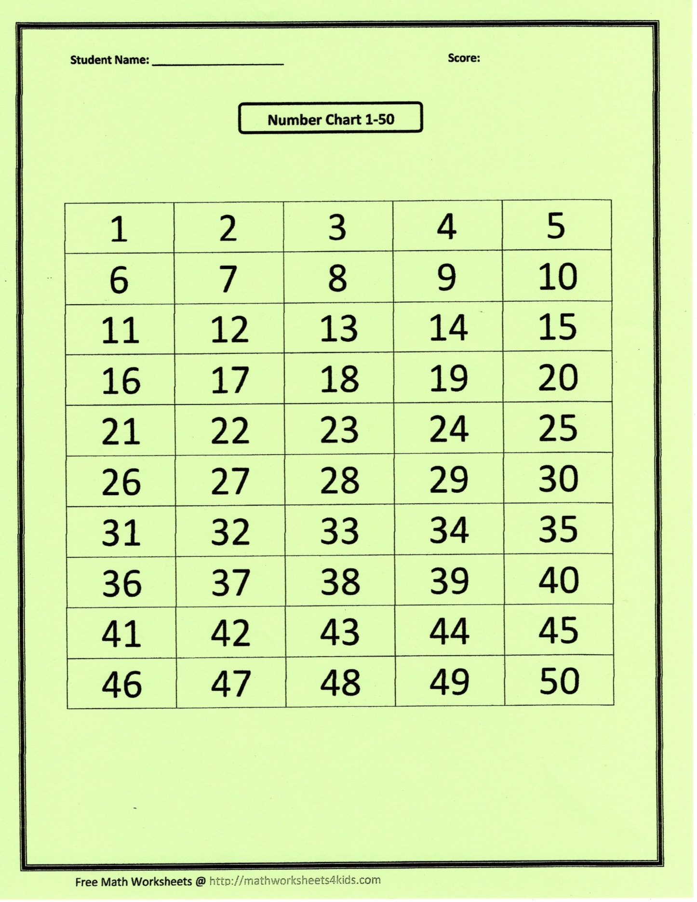

**Appendix B - Signs for the Course Lanes**

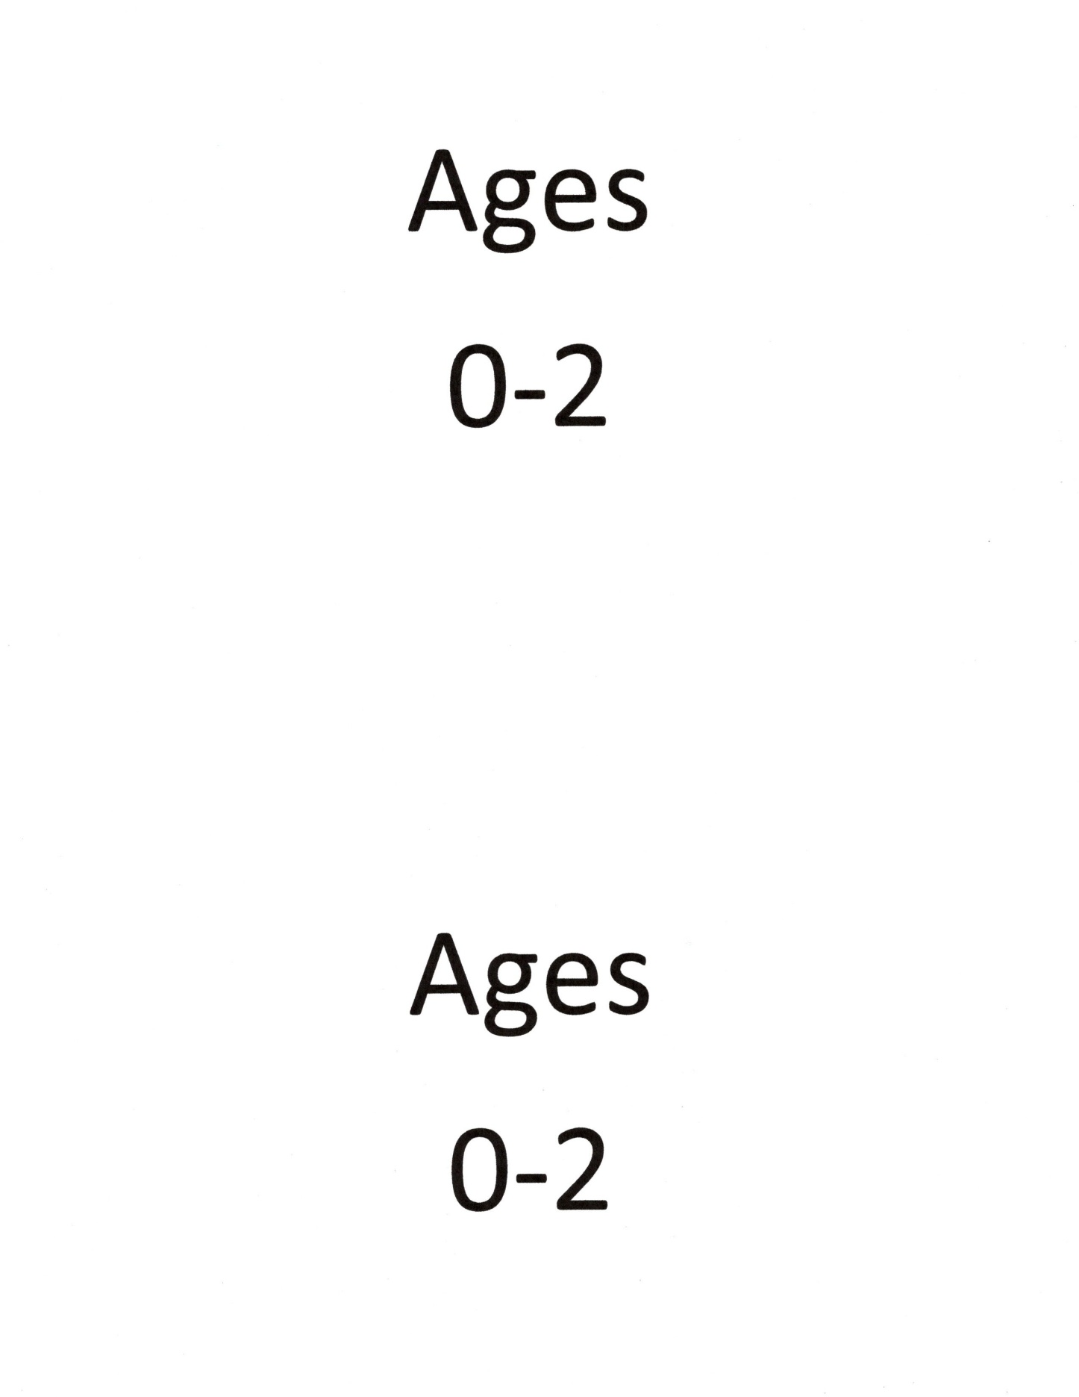

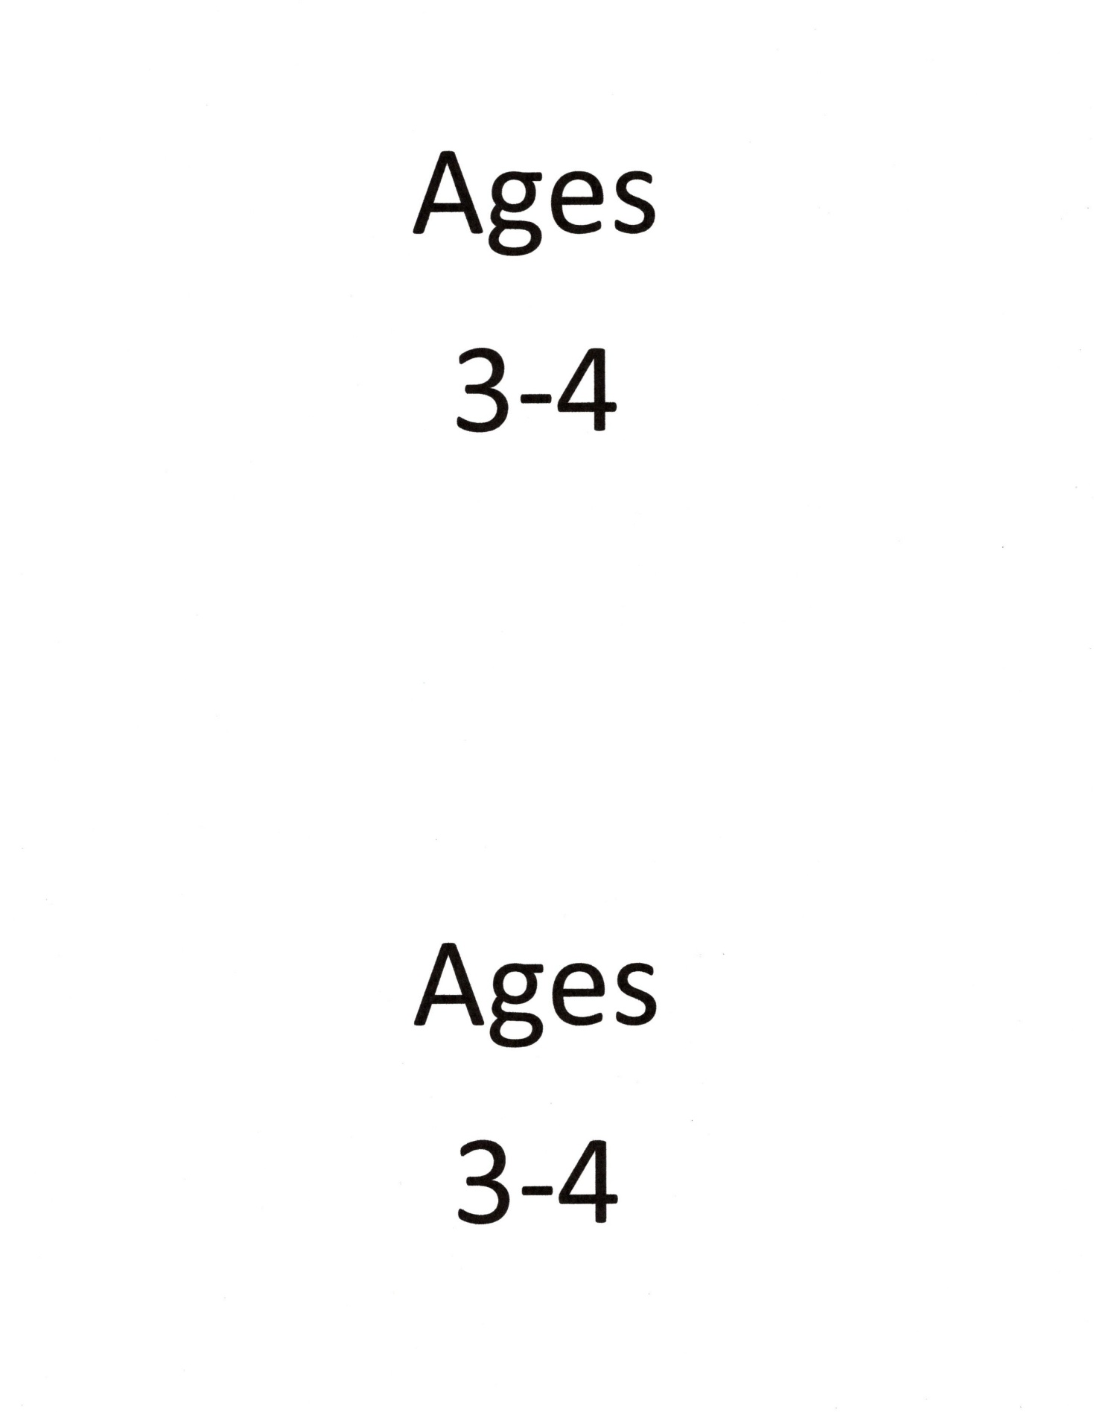

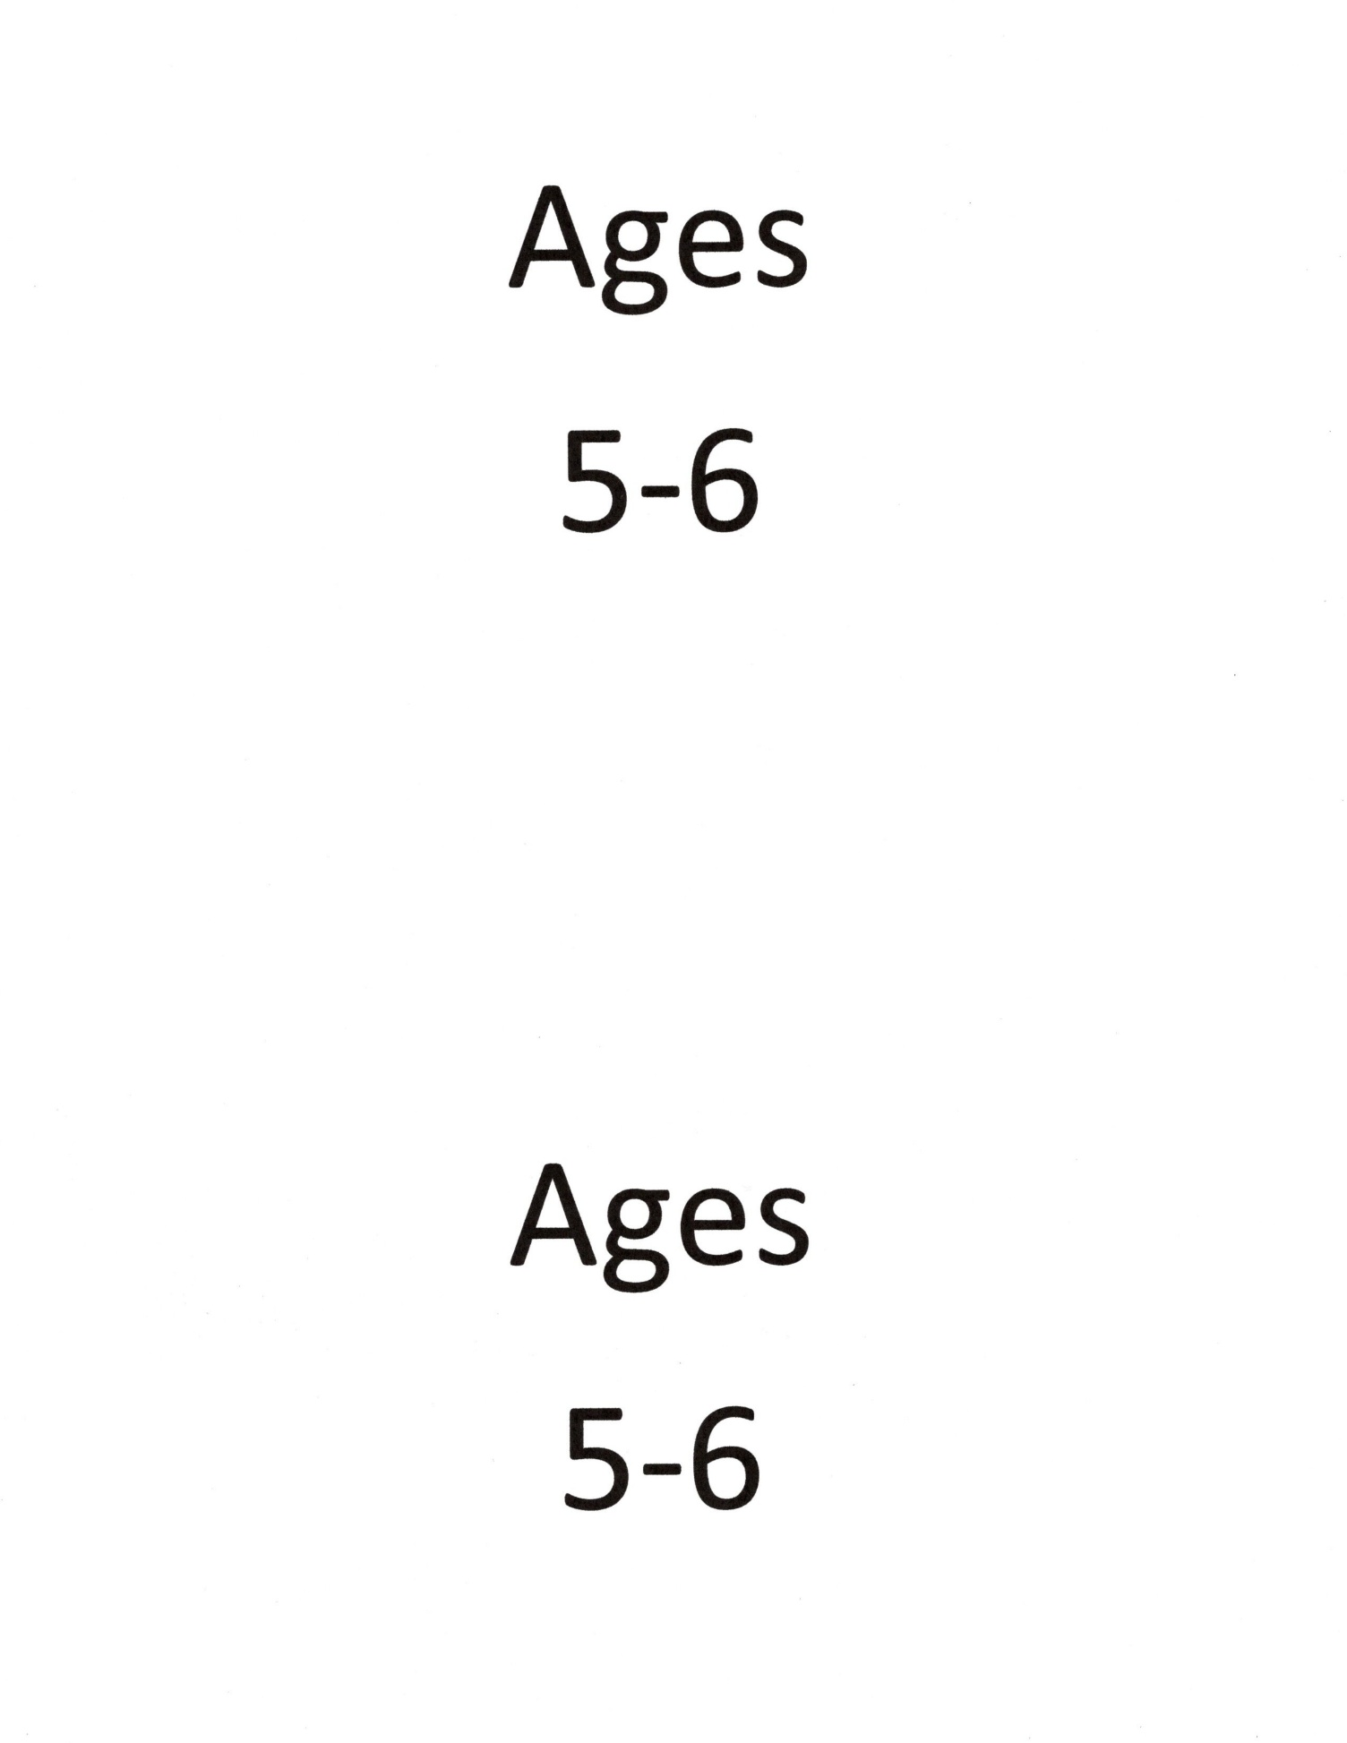

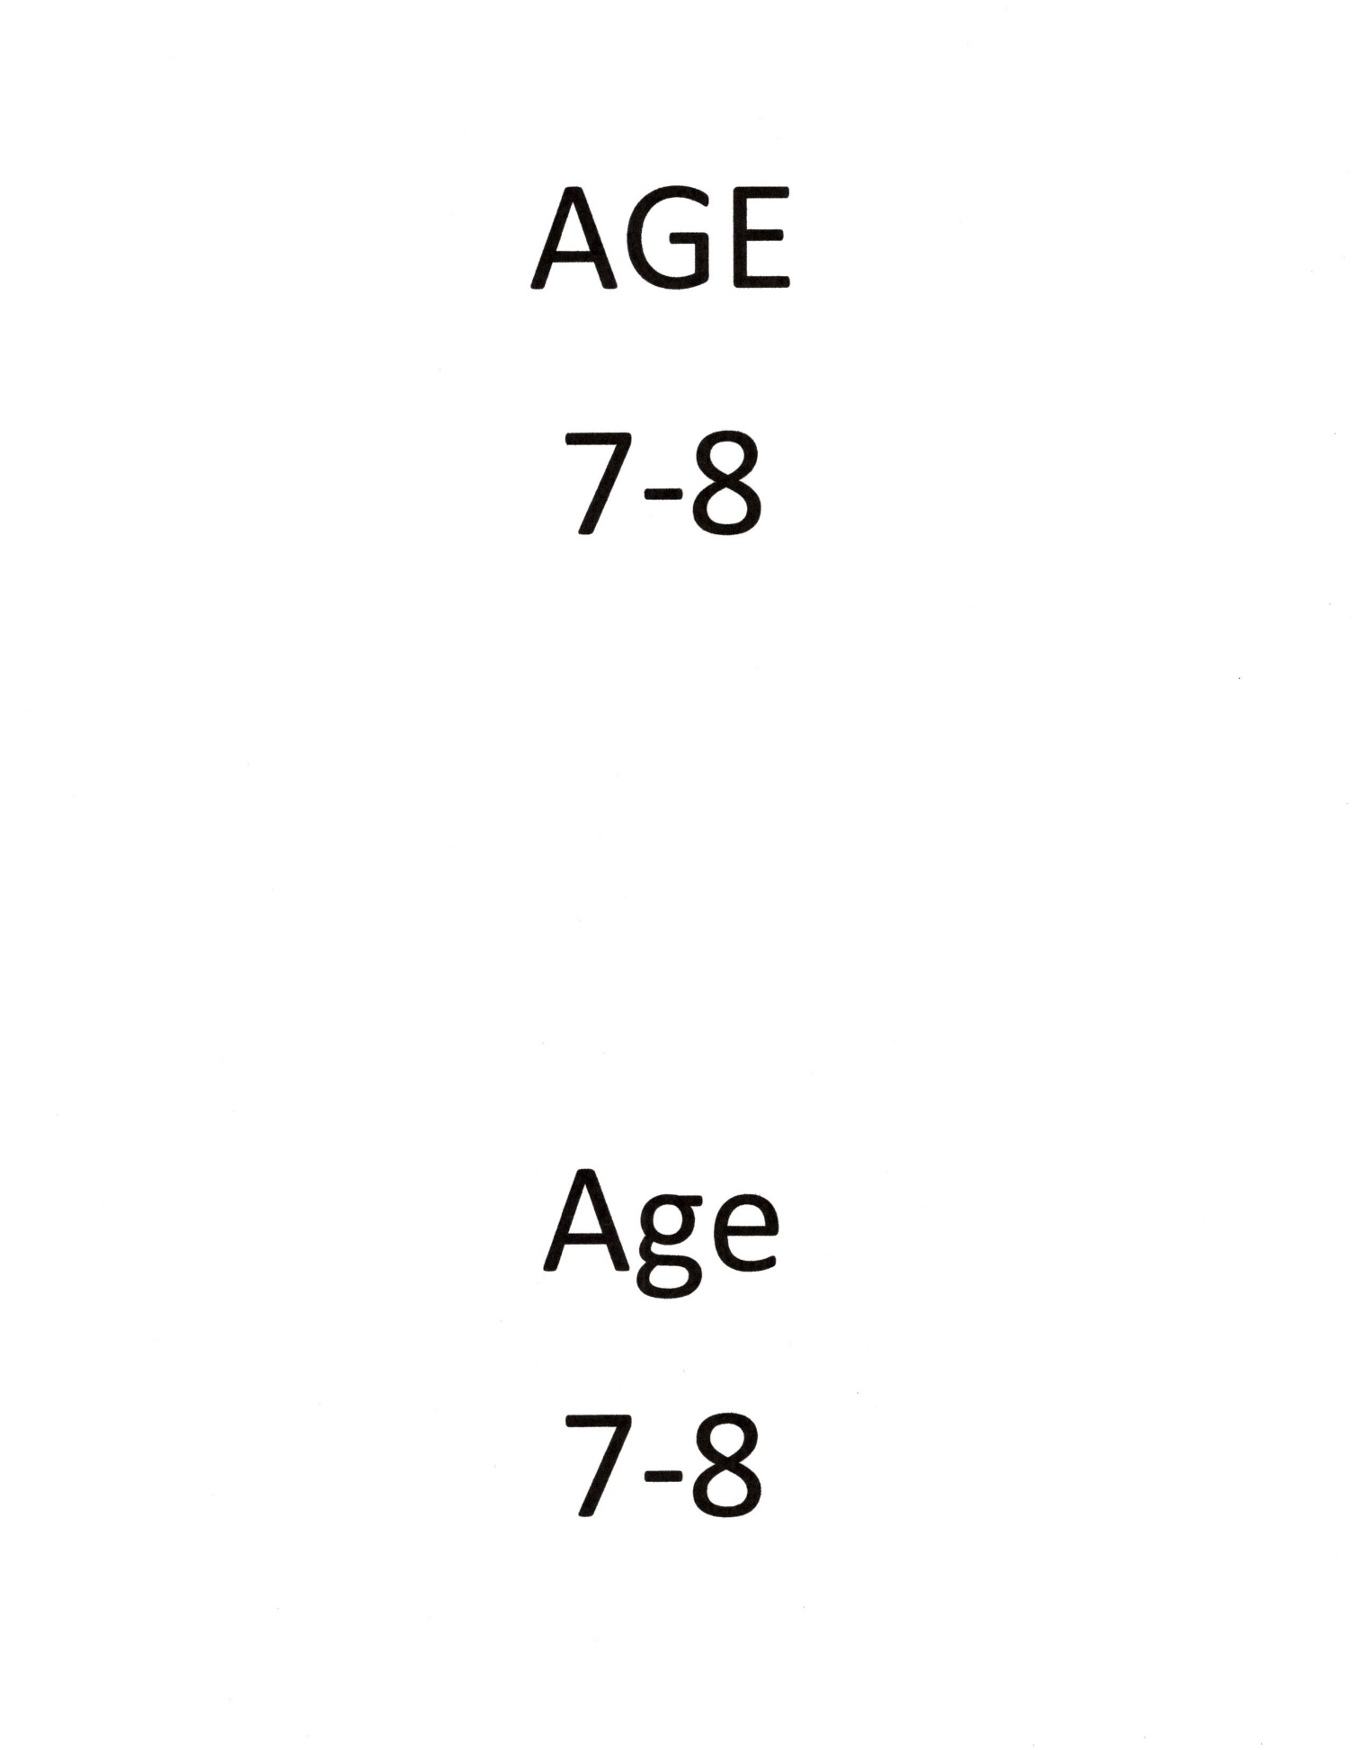

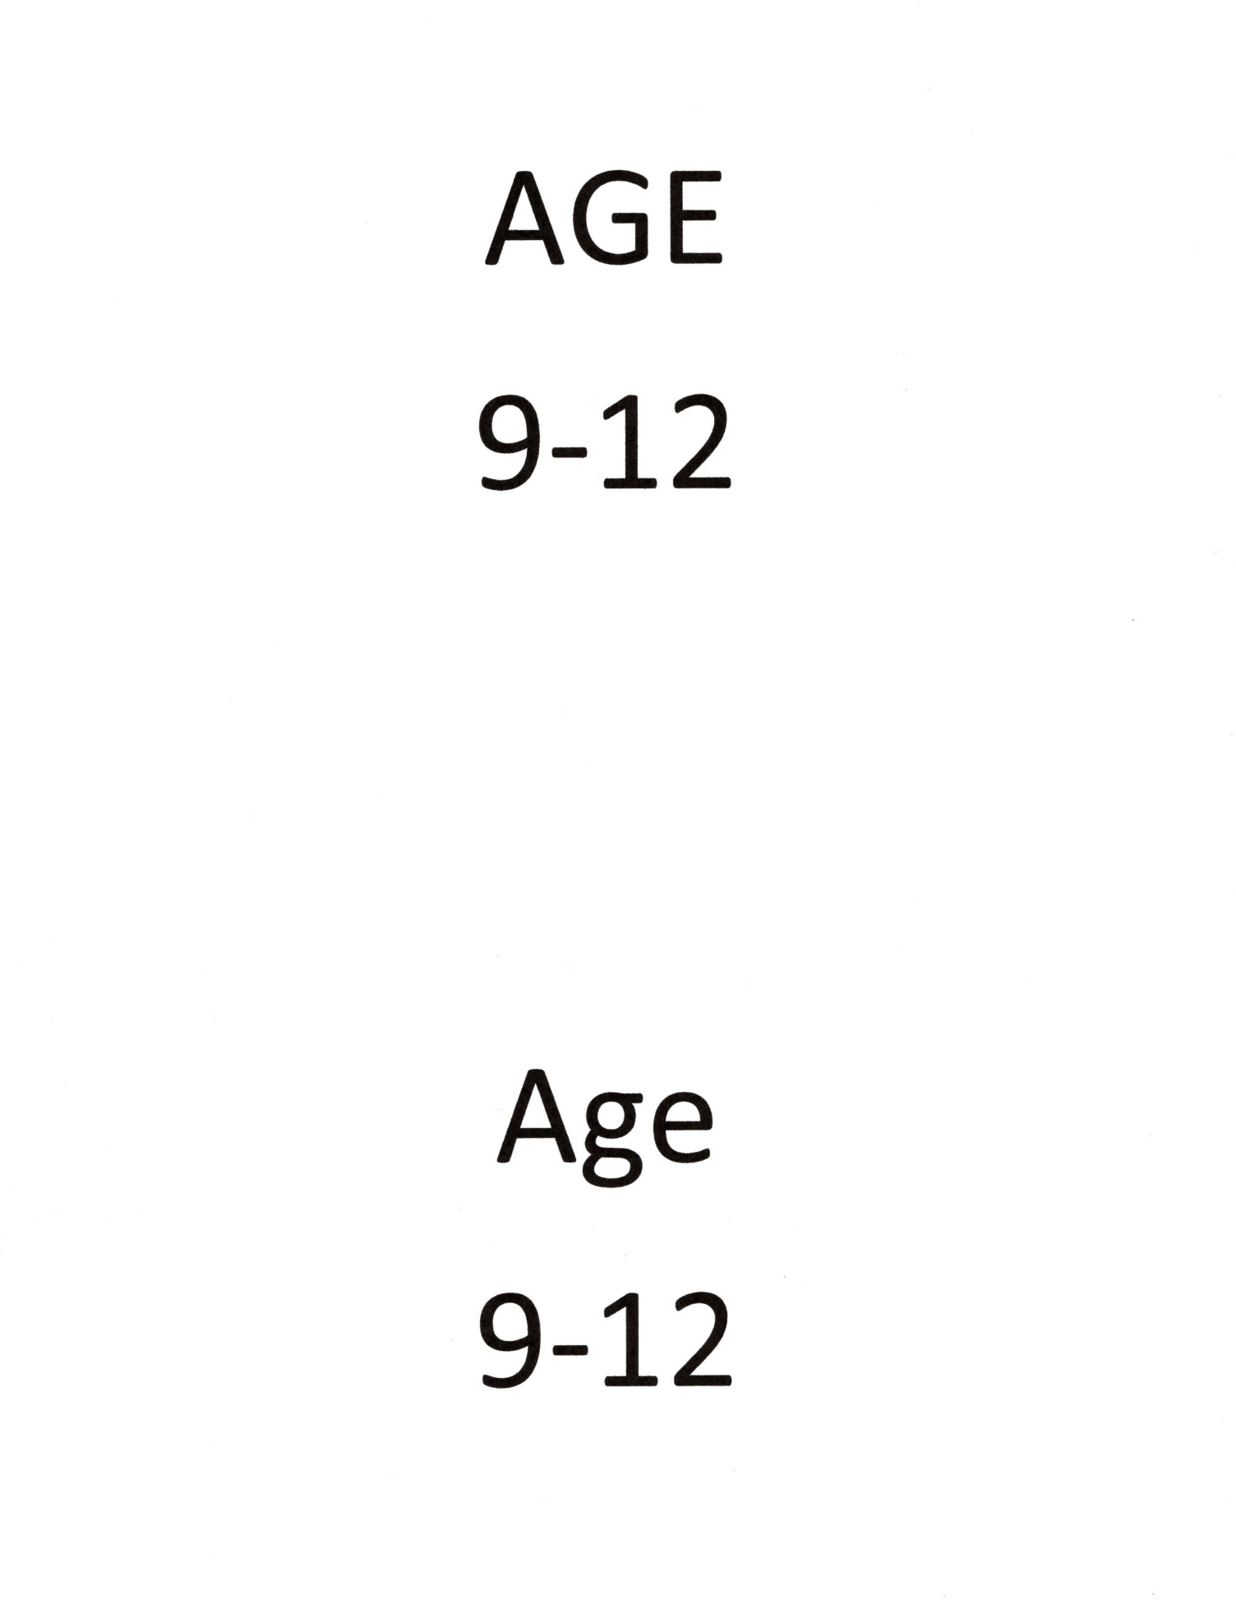

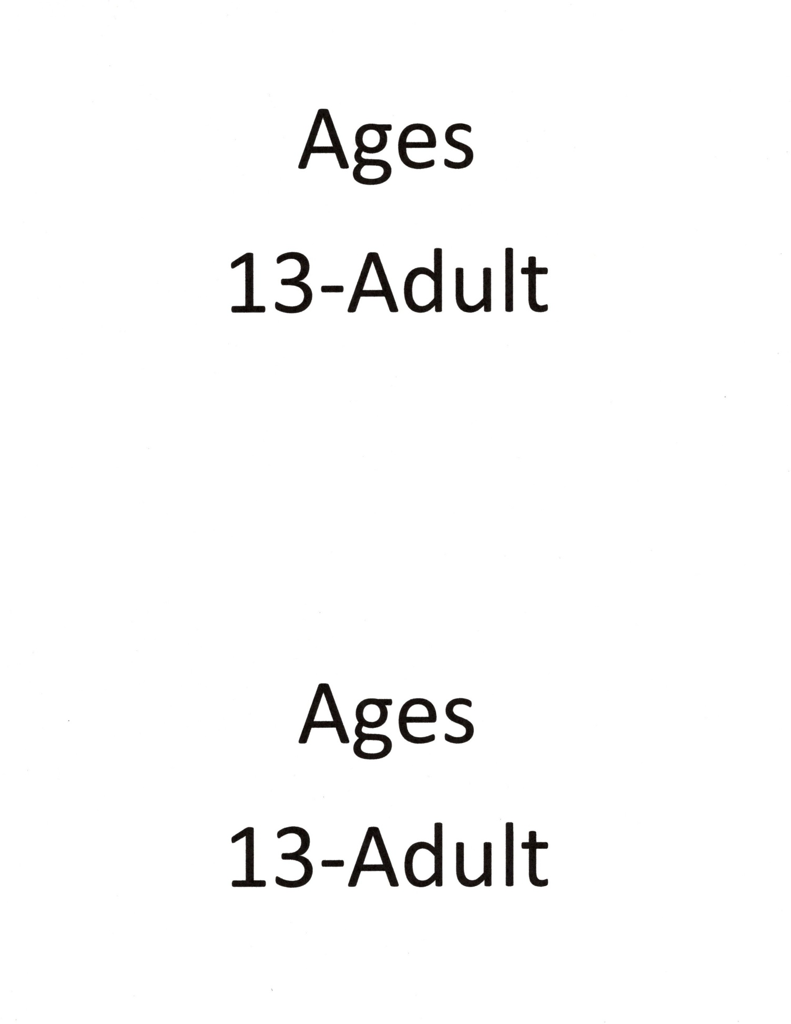

**Appendix C - Illustrative Photos**

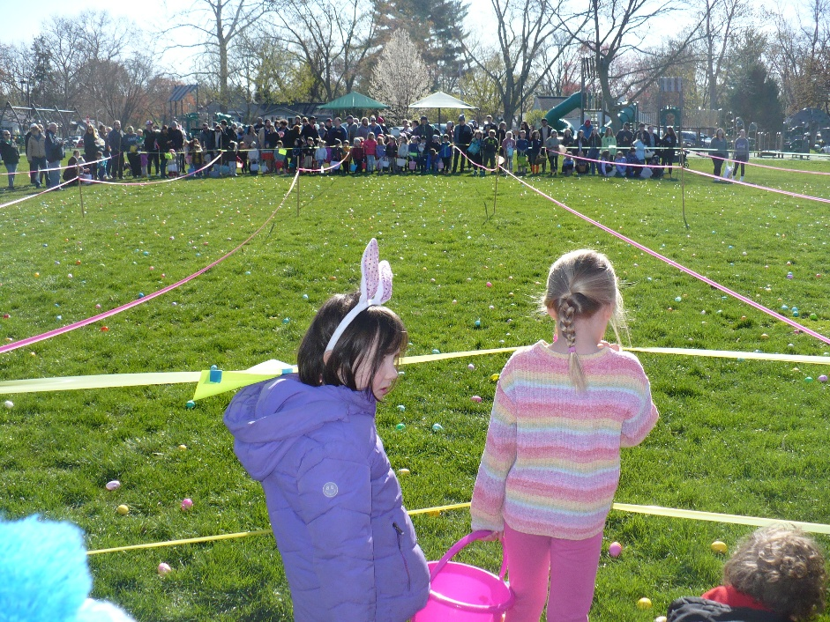

Looking east, about 4 minutes before the start of the hunt – 4/12/2025. Credit, CHCA Webmaster

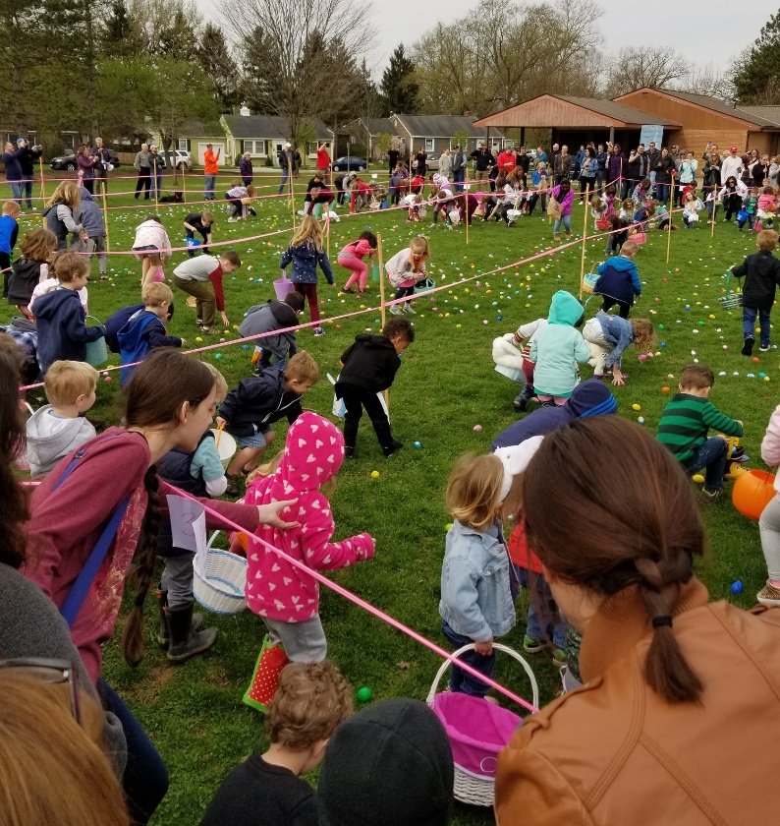

Looking west, about 30 seconds after the start of the hunt – 4/13/2019. Credit, Chris Rule

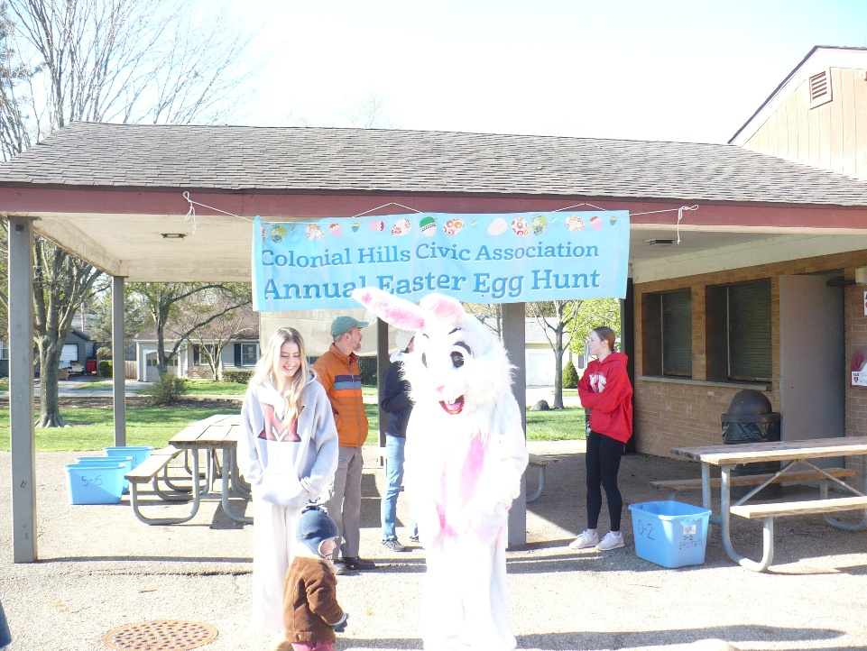

The Easter Bunny about 20 minutes before the start of the hunt, 4/12/2025. Credit, CHCA Webmaster

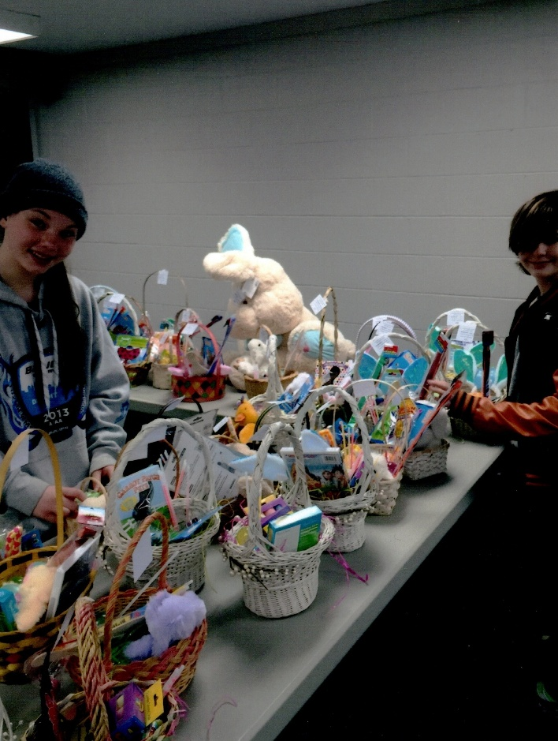

Volunteers have constructed baskets during Egg Stuffing Event, around 2017. Credit, Kathi Godber